Warrenbound: Movement and hiding



The following will explain great detail how movement and hiding in Warrenbound will work including: Rabbit movement, sneaking, sprinting, and hiding.

The Basics of Movement and Its Controls

Movement will be drawing most of its inspiration from Real Time Strategy games and how they are normally controlled. If the player right clicks on a rabbit, a dim glow should surround the rabbit signifying that the rabbit is selected. Other methods for selecting rabbits include clicking and dragging over a group of rabbits or using Ctrl click to select rabbits one at a time. Clicking on a rabbit again after it has been selected will deselect it. Deselecting will also work with the click and drag and Ctrl click methods.

After the player has a rabbit or group of rabbits selected if the player clicks a spot on the map the selected rabbits will begin to move towards that location in a straight path. If there is an object in the way they will navigate around it and continue towards the selected point. If the rabbits are spotted by a predator while moving towards the selected location, they will do one of two things depending on how close they are to the predator that sighted them. If the rabbits are spotted on the outer half of a predator’s sight the rabbits will freeze in place in place and await new orders. If the rabbits are seen in the inner half of a predators sight the rabbits will begin dashing towards random locations away from the predator. (NOTE: It has also been suggested that some sort of indicator be add to show when a rabbit can be seen or when it is hidden. We could use the indicator used in games like Skyrim, or some other method. This will be determined at a later date.)

Sprinting and Sneaking

When the player has selected rabbits and clicks on a space to move them towards they will either be sneaking or sprinting. Sneaking will make the rabbits move slowly towards their destination, making less noise in the process. Sprinting rabbits will run towards their destination, but as a consequence make more noise that could alert predators. Sneaking and sprinting will be controlled using a set of toggle keys/on screen buttons. Whichever movement option is currently selected will be shown by having the corresponding option highlighted on the screen.

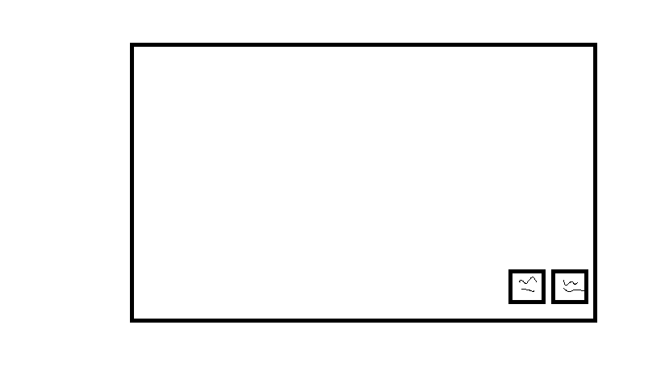

This is an example of where the sprint and sneak buttons would be relative to the rest of the screen.

Hiding

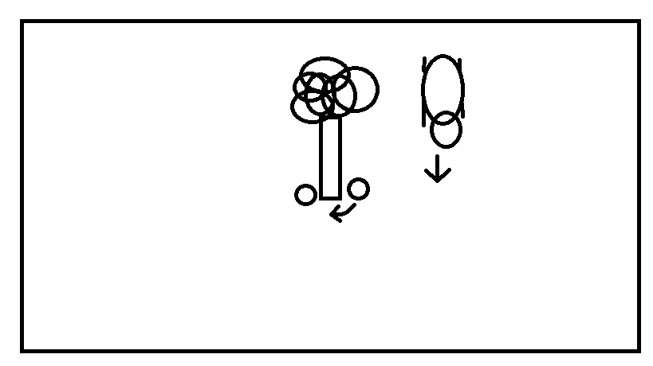One of the main mechanics to Warrenbound is using spaces or objects in the environment to hide rabbits. These hiding spots can include bushes, tall grass, trees, ditches, etc. So as to make it clear to players what in the environment is a hiding spot and what isn’t, hiding spots will give off a light glow when the player hovers the mouse over the spot. To have a rabbit hide in a hiding spot the player must select a rabbit or group of rabbits then click on the hiding spot that they want to send them to. If the hiding spot is something that can be entered like bushes or tall grass it will conceal their appearance from predators. If the hiding spot is something that can’t be entered like trees or rocks the rabbits will stay behind the object so that they are out of nearby predators’ sight. If a predator comes along from the other side the rabbits will attempt to shuffle around the object so they can stay hidden from the predator. (This action will create noise.)

An example of a rabbit moving around a tree it was hiding at to avoid being spotted by an approaching predator.

Hiding Spot Holding Limits

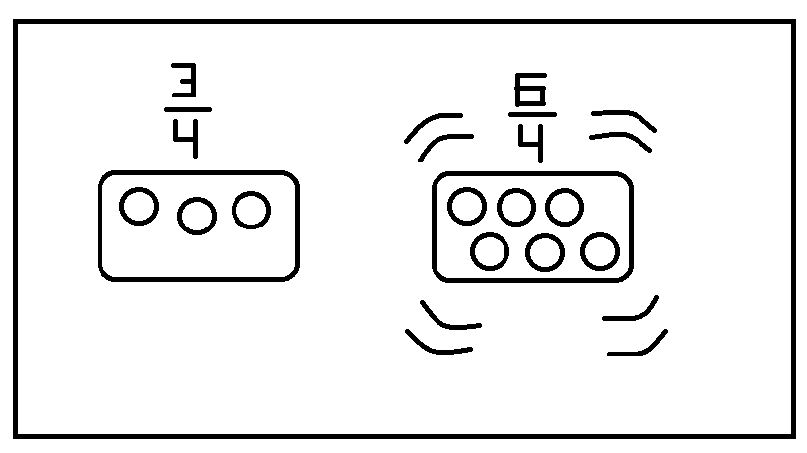The last thing to mention is that hiding spots will have holding limits. These limits will determine how many rabbits a spot can hide without compromising its effectiveness. For example, if a bush has a holding limit of 4 rabbits so long as there are 4 or less rabbits in the bush they will be completely concealed and not make any noise. If the number becomes 5 or more then they will be making noise from the spot, alerting nearby predators. A hiding spots holding limit will be shown through a fraction whenever the mouse is hovering over a hiding spot.

The left side shows when a hiding spot that is not full. The right shows a hiding spot that has surpassed its limit and is now creating noise.